IET DEPARTMENT



Sumama Rahim
F24BSCS039
12/21/2025
Data Structures

Lab 7: Stack Data Structure

Objectives:
- Stack
- Stack using Linked List Concept
- Stack using Array Concept

Practice Tasks
Lab Task 1:
Create a class Node for book that contains information about title, price, edition, and no of pages of the book. Implement your push, pop, peek books on a stack functions properly.
Now in the main:
1. Push 5 books into this stack.
2. Find the top element of the stack
3. Pop 2 books from the stack.
4. Display all the remaining books in the stack.

Solution:

// Sumama Rahim
// F24BSCS039
S
class infoBooks {

private class Book {
String title;
int price;
int edition;
int noOfPages;
Book next;
}

Book top;

infoBooks() {
this.top = null;
}

public void push(String title, int price, int edition, int noOfPages) {
Book newBook = new Book();
if (top == null) {
newBook.title = title;
newBook.price = price;
newBook.edition = edition;
newBook.noOfPages = noOfPages;
top = newBook;
} else {
newBook.title = title;
newBook.price = price;
newBook.edition = edition;
newBook.noOfPages = noOfPages;
newBook.next = top;
top = newBook;
}
}

public void top() {
if (top == null) {
System.out.println("Stack is empty!");
} else {
System.out.println("on top we have following book: \n" +
"Title : " + top.title +
", price: " + top.price +
", Edition: " + top.edition +
", Pages: " + top.noOfPages);
}
}

public void pop() {
if (top == null) {
System.out.println("Stack is empty!");
} else {
top = top.next;
}
}

public void display() {
if (top == null) {
System.out.println("Empty!");
} else {
Book S = top;
System.out.println("Books inoformation:\n-------------------------------------------------");
while (S != null) {
System.out.println("Title: " + S.title +
", Price: " + S.price +
", Edition: " + S.edition +
", Pages: " + S.noOfPages);
S = S.next; // moves to next node
}
System.out.println();
}
}
}

class Main {

public static void main(String... args) {

// 1
infoBooks list = new infoBooks();
list.push("I am Sumama", 79, 1, 1240); // prices are in GBP
list.push("Mai aur meri dunya", 69, 4, 1378);
list.push("Meri Dua", 72, 1, 780);
list.push("Kal sy parhunga - how to change this?", 98, 1, 378);
list.push("Wo din", 19, 5, 977);
// 2
list.top();
// 3
list.pop();
list.pop();
// 4
list.display();
}
}

Output:

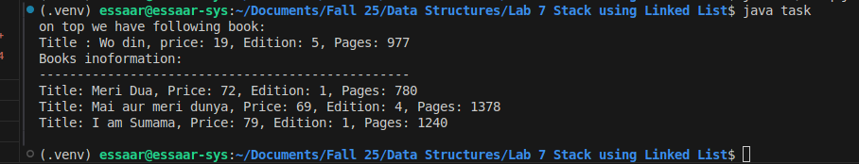

Out comes
The outcomes of this lab were:
- Stack
- Stack using Linked List Concept
- Stack using Array Concept

